Installation Manual

iChange Cloud Migration

Version 1.2

# Revision Summary

|  |  |  |  |  |
| --- | --- | --- | --- | --- |
| Version No. | Date | Revision Description | Author(s) | Approver(s) |
| 1.0 | 2022-03-25 | Initial | Ray Zhu |  |
| 1.1 | 2022-04-10 | Amendment according to Cyrus’s recommend | Ray Zhu |  |
| 1.2 | 2022-04-26 | Amendment according to Cyrus’s recommend and reply all Cyrus’s question. | Ray Zhu |  |
|  |  |  |  |  |
|  |  |  |  |  |
|  |  |  |  |  |
|  |  |  |  |  |
|  |  |  |  |  |
|  |  |  |  |  |
|  |  |  |  |  |

# Distribution List

|  |  |
| --- | --- |
| Company / Department | Person / Group |
| AIAHK Infra  / AIAHK Technology Engineering Team | Cheung Cyrus-TS; Zheng, Winner-Y |
| AIA HK CCOE team | Lam Tung Kieu, Stella Ye |
| AIA ICHANGE Support team | Paul Ng, Jansen Gao, Bru Ke |
|  |  |
|  |  |

**Table of Contents**

Revision Summary 2

Distribution List 3

1 Introduction 5

2 Setup and configurations 5

2.1 AKS namespace setup 5

2.2 Ingress setup 5

2.2.1 Ingress internet API setup 5

2.2.2 Ingress internal API setup 6

2.3 API Gateway setup 6

2.4 Application setup 6

2.5 Application verification 7

2.6 Security 8

2.7 Others 8

3 References and Remarks 9

4 Appendix 9

# Introduction

This document provides installation information for the iChange Cloud Migration.

# Setup and configurations

AKS namespace, ingress, application, APIGW are required to set up.

## AKS namespace setup

Below is the namespace for the iChange Cloud Migration. To create the namespace, a build sheet is submitted

|  |  |  |  |
| --- | --- | --- | --- |
| Category | Cluster Name | Namespace | Environment |
| Internet AKS | aks-hk01-eas-p-internet-cu03 | nsp-hk01-p-intt-eform-ef02 | PROD |
| Internal AKS | aks-hk01-eas-p-internal-cu03 | nsp-hk01-p-intl-eform-ef02 | PROD |
| POSA ACL AKS | aks-hk01-eas-p-internal-cu03 | nsp-hk01-p-intl-xgfe-pos01 | PROD |

## Ingress setup

### Ingress internet API setup

Deployment requests have been submitted to Technology Engineering Team for setting up the internet ingress in AKS.

[[EFORM-5547] UTRF - IChangeCloud-EC-Ingress For PROD On Apr 15 7:00 PM - AIAHK Jira (aiaazure.biz)](https://aiahk-jira.aiaazure.biz/browse/EFORM-5547)

1. **Create Secrets**

Upload the following certificate, key and script files to deployment machine

* aiahk-eform-ext-prod.aiaazure.biz.cer
* aiahk-eform-ext-prod.aiaazure.biz.key

The cert and key can be found at:

<https://aiahk-bitbucket.aiaazure.biz/projects/EFORM/repos/eform-aiaazure-cert/browse/cloud-san/prod>

1. **Execute command below to create the secrets – AIAHK CCOE Team**

|  |
| --- |
| # kubectl create secret tls secret-hk01-eas-p-aes-eform-ext-api --cert <path>/aiahk-eform-ext-prod.aiaazure.biz.cer --key <path>/aiahk-eform-ext-prod.aiaazure.biz.key -n nsp-hk01-p-intt-eform-ef02 --cluster aks-hk01-eas-p-internet-cu03 |

1. **Create and configure Ingress**
   * Yaml files can be found in the below Bitbucket repository:

<https://aiahk-bitbucket.aiaazure.biz/projects/EFORM/repos/aks-ingress/browse/ichangecloud-ec-ingress/base>

* + Refer below Ingress deployment guideline

<https://aiahk-confluence.aiaazure.biz/display/ADG/Ingress+Deployment+Guideline>

### Ingress internal API setup

Deployment requests have been submitted to Technology Engineering Team for setting up the internal ingress in AKS.

[[EFORM-5546] UTRF - IChangeCloud-PC-Ingress For PROD On Apr 15 7:00 PM - AIAHK Jira (aiaazure.biz)](https://aiahk-jira.aiaazure.biz/browse/EFORM-5546)

1. **Create Secrets**

Upload the following certificate, key and script files to deployment machine

* aiahk-eform-intl-prod.aiaazure.biz.cer
* aiahk-eform-intl-prod.aiaazure.biz.key

The cert and key can be found at:

<https://aiahk-bitbucket.aiaazure.biz/projects/EFORM/repos/eform-aiaazure-cert/browse/cloud-san/prod>

1. **Execute command below to create the secrets – AIAHK CCOE Team**

|  |
| --- |
| # kubectl create secret tls secret-hk01-eas-p-aes-eform-intl-api --cert <path>/aiahk-eform-intl-prod.aiaazure.biz.cer --key <path>/aiahk-eform-intl-prod.aiaazure.biz.key -n nsp-hk01-p-intl-eform-ef02 --cluster aks-hk01-eas-p-internal-cu03 |

1. **Create and configure Ingress**

* Yaml files can be found in the below Bitbucket repository:

<https://aiahk-bitbucket.aiaazure.biz/projects/EFORM/repos/aks-ingress/browse/ichangeCloud-ingress/base>

* Refer below Ingress deployment guideline

<https://aiahk-confluence.aiaazure.biz/display/ADG/Ingress+Deployment+Guideline>

## API Gateway setup

To deploy the APIGW, API swagger and SS JIRA tickets will be required. The iChange Support team fills in the APIGW deployment form and creates the SS ticket.

* API GW2: https://aiahk-jira.aiaazure.biz/browse/SS-6426
* API GW3: https://aiahk-jira.aiaazure.biz/browse/SS-6428
* API GW4: https://aiahk-jira.aiaazure.biz/browse/SS-6427

## Application setup

To deploy the iChange Cloud Migration adopts the DevOps pipeline. Please refer to the below guidelines.

<https://aiahk-confluence.aiaazure.biz/pages/viewpage.action?spaceKey=ADG&title=DevOps+Deployment+Operation+Manual>

The YAML file can be found in the below Bitbucket repository.

* Internet AKS:

<https://aiahk-bitbucket.aiaazure.biz/projects/EFORM/repos/aks-deployment/browse/ichangecloud-ec/base>

* Internal AKS:

<https://aiahk-bitbucket.aiaazure.biz/projects/EFORM/repos/aks-deployment/browse/ichangecloud-pc/base>

* ACL AKS:

<https://aiahk-bitbucket.aiaazure.biz/projects/EFORM/repos/aks-deployment/browse/ichangecloud-posa-acl/base>

## Application verification

After the above components are deployed, the developer can verify the function by performing the following action as a minimum to verify that the iChange application is running and its connections are functioning.

* iChange AKS:

Refer to the steps for application check:

1. Add a new request with name ‘iChange-checkServer’;
2. Set request type is ‘POST’, and the request URL is:

<https://aiahk-apigw3-prd.aia.com.hk/gateway/digital.sub-eform-ec/v1.0/base/v1/check-server>

1. Add header attributes for the request:
2. x-Gateway-APIKey
3. Origin
4. Click ‘Send’ button to send the request and verify the response:

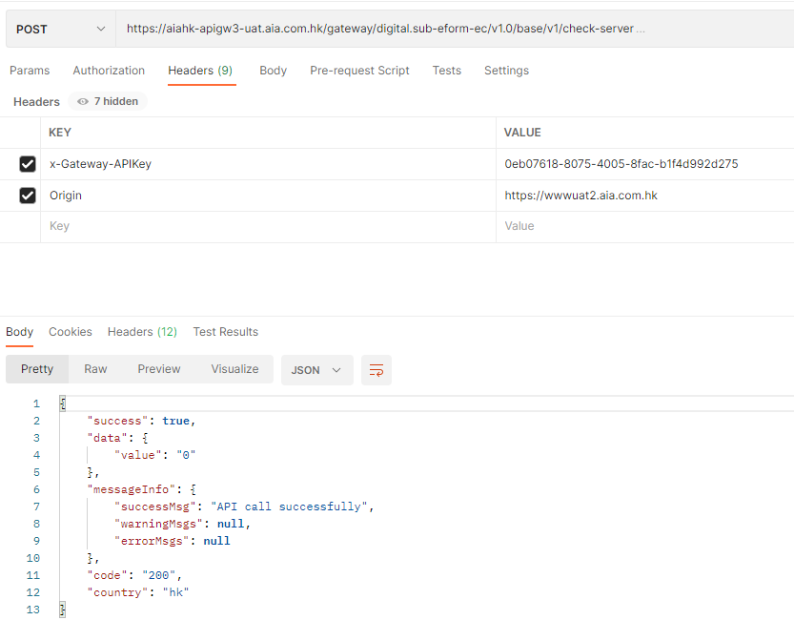

On Postman, call the API endpoint as below and check if the response is shown as expected:

|  |  |
| --- | --- |
| Request | |
| Type | POST |
| Endpoint | <https://aiahk-apigw3-prd.aia.com.hk/gateway/digital.sub-eform-ec/v1.0/base/v1/check-server> |
| Header |  |
|  |  |
| Response | |
| Type | Json |
| Content | {  "success": true,  "data": {  "value": "0"  },  "messageInfo": {  "successMsg": "API call successfully",  "warningMsgs": null,  "errorMsgs": null  },  "code": "200",  "country": "hk"  } |

## Security

N/A

## Others

N/A

# References and Remarks

N/A

# Appendix

N/A